# Switching Techniques

In large networks, there may be more than one paths for transmitting data from **sender** to receiver. Selecting a path that data must take out of the available options is called **switching**. There are two popular switching techniques – circuit switching and packet switching.

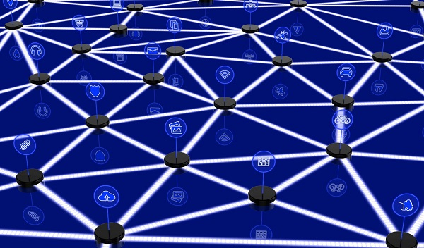

**Network Switching**

**Definition**

Network switching is the process of transmitting data packets from the source to the destination through a number of intermediate network nodes. Here, each node controls or switches data packets to the next node towards the destination. When data comes on a node it is called ingress, and when data goes out of a node it is called egress.

**Switching Methods**

The two broad level switching methods are connection oriented switching and connectionless switching.

* **Connection – oriented Switching** : In connection – oriented switching, a dedicated path is established between the source and the destination before data switching. Once this path is established, the entire message sent through this route.
* **Connectionless Switching** : In connectionless switching, no path is established prior to data switching. Each data unit has complete address information and is individually routed from the source to the destination using forwarding tables of the nodes.

**Switching Techniques**

The three common switching techniques are circuit switching, packet switching and message switching −

* **Circuit Switching** : Here, a dedicated path is established between the source and the destination and then all the message is sent over this route. It is an example of connection – oriented switching method.
* **Packet Switching** : The entire message is broken down into small data packets each of which has switching information in its header. The packets are then individually routed from the source to the destination. The destination node reassembles out-of-order packets according to header information. It is an example of connectionless switching.
* **Message Switching** : It is a combination of circuit switching and message switching. Here, the entire message is considered as a data unit and is routed from one node to another in a connectionless manner.

**Circuit-switched vs Packet-switched networks**

**Definitions**

**Circuit Switched Networks** − Circuit switched networks are connection-oriented networks. Here, a dedicated route is established between the source and the destination and the entire message is transferred through it.

**Packet Switched Networks** − Packet switched networks are connectionless networks. Here, the message is divided and grouped into a number of units called packets that are individually routed from the source to the destination.

**Comparisons**

**Differences with respect to technology**

|  |  |  |
| --- | --- | --- |
| **Serial Number** | **Circuit – Switching** | **Packet – Switching** |
| 1 | It is a connection oriented network switching technique. | It is a connectionless network switching technique. |
| 2 | A dedicated path has to be established between the source and the destination before transfer of data commences. Once, the data is transmitted, the path is relinquished. | There is no need to establish a dedicated path from the source to the destination. |
| 3 | It is inflexible in nature since data packets are routed along the same dedicated path. | Each packet is routed separately. Consequently, it is flexible in nature where the different data packets follow different paths. |
| 4 | It was initially designed for voice transfer. | It was initially designed for data transfer. |
| 5 | The entire message is received in the order sent by the source. | The individual packets of the message are received out of order and so need to be reassembled at the destination. |
| 6 | It is implemented at Physical Layer. | It is implemented at Network Layer. |
| 7 | It has two approaches −   * Space division switching, and * Time division switching | It has two approaches −   * Datagram, and * Virtual Circuit |
| 8 | It is not a store and forward transmission. | It is store and forward transmission. |
| 9 | Data is processed and transmitted at the source only. | Data is processed and transmitted, not only at the source but at each switching station. |

**Differences with respect to applicability, advantages and disadvantages.**

|  |  |  |
| --- | --- | --- |
| **Serial Number** | **Circuit – Switching Networks** | **Packet – Switching Networks** |
| 1 | They are suitable for long continuous transmission, like voice calls. | They are unsuitable for applications that cannot afford delays in communication like high quality voice calls. |
| 2 | Once a route is established between the source and the destination, the route cannot be used by any other user. This leads to poor utilization of resources. | It allows simultaneous usage of the same channel by multiple users. This guarantees better resource utilization. |
| 3 | Bandwidth requirement is high even in cases of low data volume. | It ensures better bandwidth usage as a number of packets from multiple sources can be transferred via the same link. |
| 4 | Time required to establish connection may be high. | Delay in delivery of packets is less, since packets are sent as soon as they are available. |
| 5 | Initial cost is low. | Packet switching high installation costs. |
| 6 | The protocols for delivery are relatively simpler. | They require complex protocols for delivery. |
| 7 | It is more reliable. | It is less reliable. |

**Diagrammatic Representations**

q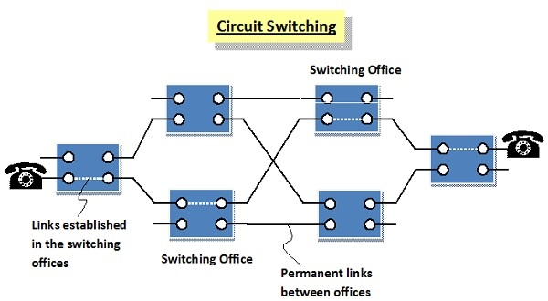

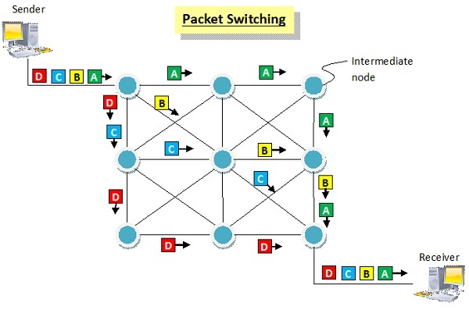

**Circuit Switching**

Circuit switching is a connection-oriented network switching technique. Here, a dedicated route is established between the source and the destination and the entire message is transferred through it.

**Phases of Circuit Switch Connection**

* **Circuit Establishment** : In this phase, a dedicated circuit is established from the source to the destination through a number of intermediate switching centres. The sender and receiver transmits communication signals to request and acknowledge establishment of circuits.
* **Data Transfer** : Once the circuit has been established, data and voice are transferred from the source to the destination. The dedicated connection remains as long as the end parties communicate.
* **Circuit Disconnection** : When data transfer is complete, the connection is relinquished. The disconnection is initiated by any one of the user. Disconnection involves removal of all intermediate links from the sender to the receiver.

**Diagrammatic Representation of Circuit Switching in Telephone**

The following diagram represents circuit established between two telephones connected by circuit switched connection. The blue boxes represent the switching offices and their connection with other switching offices. The black lines connecting the switching offices represents the permanent link between the offices. When a connection is requested, links are established within the switching offices as denoted by white dotted lines, in a manner so that a dedicated circuit is established between the communicating parties. The links remains as long as communication continues.

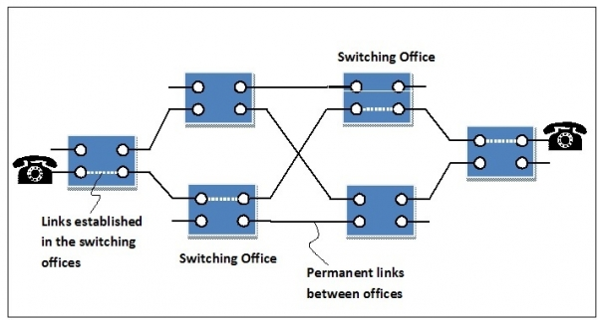

**Advantages and Disadvantages of Circuit Switching**

**Advantages**

* It is suitable for long continuous transmission, since a continuous transmission route is established, that remains throughout the conversation.
* The dedicated path ensures a steady data rate of communication.
* No intermediate delays are found once the circuit is established. So, they are suitable for real time communication of both voice and data transmission.

**Disadvantages**

* Circuit switching establishes a dedicated connection between the end parties. This dedicated connection cannot be used for transmitting any other data, even if the data load is very low.
* Bandwidth requirement is high even in cases of low data volume.
* There is underutilization of system resources. Once resources are allocated to a particular connection, they cannot be used for other connections.
* Time required to establish connection may be high.

**Packet Switching**

Packet switching is a connectionless network switching technique. Here, the message is divided and grouped into a number of units called packets that are individually routed from the source to the destination. There is no need to establish a dedicated circuit for communication.

**Process**

Each packet in a packet switching technique has two parts: a header and a payload. The header contains the addressing information of the packet and is used by the intermediate routers to direct it towards its destination. The payload carries the actual data.

A packet is transmitted as soon as it is available in a node, based upon its header information. The packets of a message are not routed via the same path. So, the packets in the message arrives in the destination out of order. It is the responsibility of the destination to reorder the packets in order to retrieve the original message.

The process is diagrammatically represented in the following figure. Here the message comprises of four packets, A, B, C and D, which may follow different routes from the sender to the receiver.

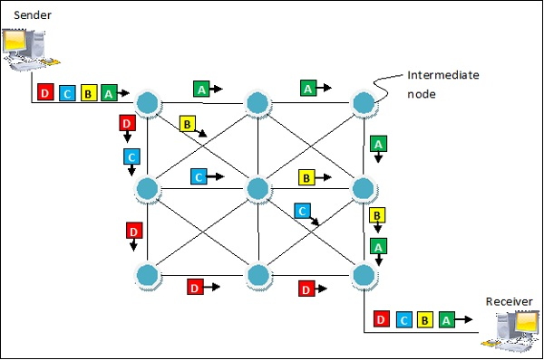

**Advantages and Disadvantages of Packet Switching**

**Advantages**

* Delay in delivery of packets is less, since packets are sent as soon as they are available.
* Switching devices don’t require massive storage, since they don’t have to store the entire messages before forwarding them to the next node.
* Data delivery can continue even if some parts of the network faces link failure. Packets can be routed via other paths.
* It allows simultaneous usage of the same channel by multiple users.
* It ensures better bandwidth usage as a number of packets from multiple sources can be transferred via the same link.

**Disadvantages**

* They are unsuitable for applications that cannot afford delays in communication like high quality voice calls.
* Packet switching high installation costs.
* They require complex protocols for delivery.
* Network problems may introduce errors in packets, delay in delivery of packets or loss of packets. If not properly handled, this may lead to loss of critical information.